<>-<>-<>-<>-<>-<>-<>-<>-<>
準備階段 Preparation Period
2024.05.09
選題確定爲「炸彈人」。 The topic chosen was Bomberman.
------------ CUT LINE ------------
2024.05.11
遊戲整體劇情、功能介紹、製作方案策劃書完成。遊戲名稱確定爲「逃出杰哥的手掌心」。The overall game plot, function introduction, and production plan are completed. The title of the game is determined to be “Escape from Bro Jie's Palm.”

<>-<>-<>-<>-<>-<>-<>-<>-<>
製作階段 Producing Period
試玩嘗鮮版 Ver 0.0.0 (Lite)
2024.05.13
「過客天」美術工作�}展。 “GKT's” started his art work.
------------ CUT LINE ------------
2024.05.16
「化學醬あずみ」聲音工作�}展並於當日完成。 “KagakuChanAzumi” started her audio work and finished it before the end of that day.
------------ CUT LINE ------------
2024.05.17
「過客天」美術工作完成。 GKT's finished his art work.
「化學醬あずみ」�{序工作�}展。 “KagakuChanAzumi” started her programming work.
------------ CUT LINE ------------
2024.05.19
「化學醬あずみ」�{序工作基本完成，�}始第一次調試。“KagakuChanAzumi” basically completed her programming work and began the first debugging.
報告BUG | Bug Report
- IDE無報錯，但在點擊「START」後遊戲�{序按鈕運行卡死。 The IDE reported no error, but the game program froze after clicking the "START" button.
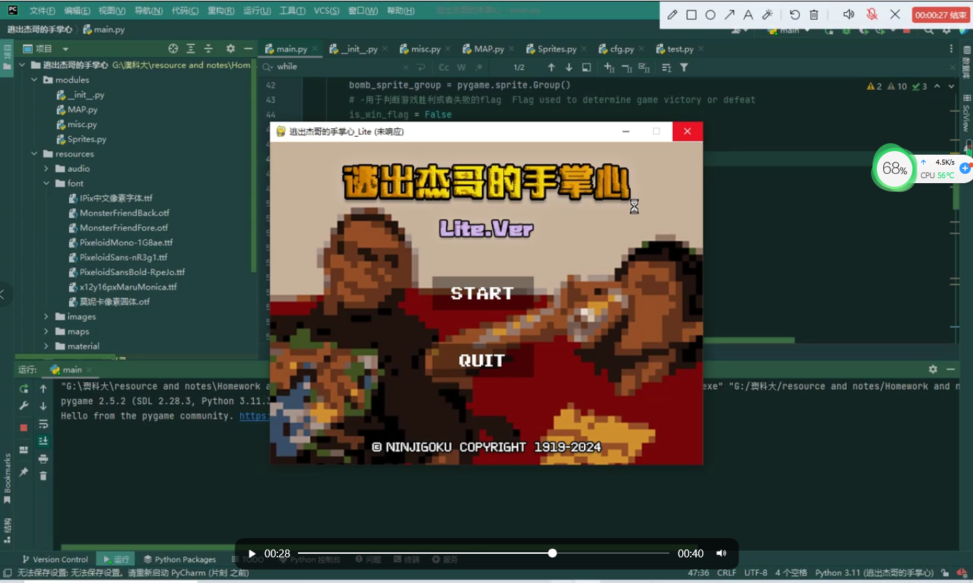
The process ended with exit code -805306369 (0xCFFFFFFF)
√ SOLVED | × UNSOLVED
- 自定義字體文件無法正常搭載渲染。 Custom font files cannot be rendered properly.
√ SOLVED | × UNSOLVED

------------ CUT LINE ------------
2024.05.20
修復BUG | Bug Repair
- 問題出在「地圖讀取」進�{上。由於地圖文件（*.map）不是Python文件（*.py），因此無法識別有註釋功能的井號。換而言之，地圖文件只應該出�{「MAP.py」文件中已定義的佔位符「w, x, z, 0, 1, 2」，若不標準就會導致解析出錯。 The problem lies in the "map reading" process. Since the map file (*.map) is not a Python file (*.py), the hash mark with comment function cannot be recognized. In other words, the map file should only contain the placeholders "w, x, z, 0, 1, 2" defined in the "MAP.py" file. If it is not standard, it will cause parsing errors.
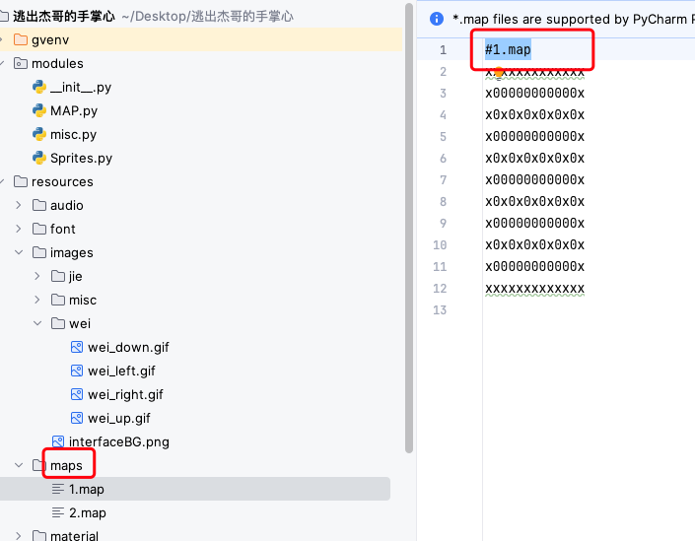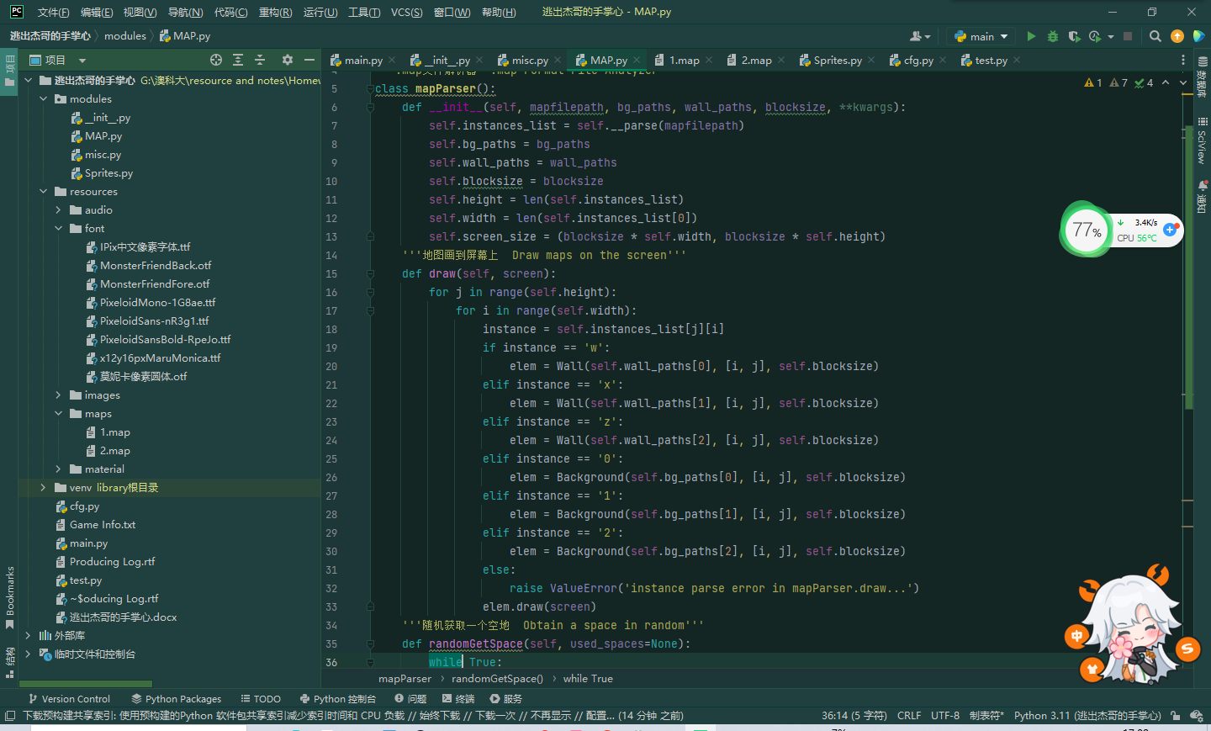
√ SOLVED | ~ SOLVING | × UNSOLVED
- 排除所有使用的庫本身之問題後，將排查方向定在「字體文件本身有問題或Pygame模塊無法識別」「出�{無效代碼」上。使用Copilot AI生成一段搭載疑似有問題的該字體的代碼進行渲染，發�{可以正常顯示，「文件本身或無法識別」問題排除，接下來將重心放在「無效代碼」上。排查功能所在區段代碼，發�{下方的按鈕分類覆蓋了上方的按鈕定義，導致「按鈕」部分完全無效。後續在已定義的「__init__」函數下進行修改，用新變量指向了自定義字體的根目錄位置，再次運行，字體已正常顯示。 After eliminating all problems with the library itself, the troubleshooting direction is set on "there is a problem with the font file itself or the Pygame module cannot recognize it" and "invalid code appears". Use Copilot AI to generate a code section containing the suspected problematic font for rendering. It is found that it can be displayed normally. The problem of "the file itself may not be recognized" is eliminated. Next, the focus will be on "invalid code". After checking the section code where the function is located, we found that the button category below covered the button definition above, causing the "button" part to be completely invalid. Subsequent modifications were made under the defined "__init__" function, using new variables to point to the root directory location of the custom font, and running again, the font was displayed normally.
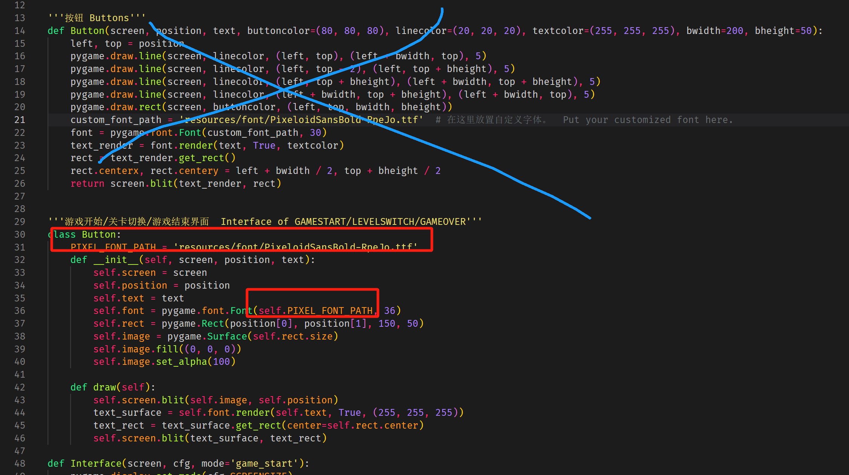
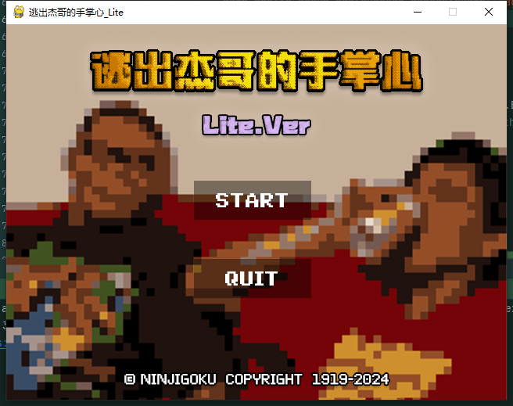

√ SOLVED | ~ SOLVING | × UNSOLVED
------------ CUT LINE ------------
2024.05.21
繼續修改UI部分的代碼，使其更加美觀、並有效提升人機關係。 Continue to modify the code of the UI part in order to make it more beautiful and effectively improve the human-machine relationship.
問題歸檔 | Issue Archive
- 第一關窗口尺寸過小。 The size of LEVEL 1 is too small. √
- 人物移動速度過慢。 The character moves too slowly. ×
- GIF動畫無法正常顯示動作（靜態）。 GIF animations do not display motion (statically) properly. ~
- 炸彈爆炸時間太長。 The bomb took too long to explode. √
- 文字顯示不清晰，需更改顏色、字號、效果等。 The text display is not clear and the color, font size, effect, etc. need to be changed. ~
吐槽區 | Complaint Area
這個源碼本身有比較多的缺陷，例如按鍵之後人物反饋時間長，移動不連貫等等。之後在�}發正式版本時，會考�{更換一個新的源碼體系。 This source code itself has many flaws, such as long character feedback time after pressing the button, inconsistent movement, etc. Later, when developing the official version, we will consider replacing it with a new source code system.

√ SOLVED | ~ SOLVING | × UNSOLVED

------------ CUT LINE ------------
2024.05.22
繼續修改功能部分的代碼。 Continue to modify the code of the Function part.
問題歸檔 | Issue Archive
- 在搭載完其他的UI物件後，響應速度又明顯變慢，猜測可能與計算時間長響應慢有關。 After loading other UI objects, the response speed became significantly slower. It is speculated that it may be related to the long calculation time and slow response. ×
- 部分新的牆壁（家具）素材導入後，原本明明是透明底的png圖片變成了白色底。 After some new wall (furniture) materials were imported, the original PNG images with a transparent background turned into a white background. ×
- 爆炸音效一直在Loop，即使用了“Sound.stop()”也無濟於事。 The explosion sound effect is always in the loop, even if “Sound.stop()” is used, it does not help at all. ~
- 無法理解倒計時區域代碼，亦不知如何修改代碼使得其可以按照正確的時間去顯示（5、4、3、2、1，歸0時爆炸。） I can't understand the countdown area code, and I don't know how to modify the code so that it can be displayed according to the correct time (5, 4, 3, 2, 1, and explode when it returns to 0.) ×
- 添加了按下Esc鍵之後退出遊戲的相關代碼，但並不起作用，只有已有的按鈕有效。 I tried to add relevant code to exit the game after pressing the ESC key, but it didn’t not work, only the existing buttons worked. ×
吐槽區 | Complaint Area
已經在嗶哩嗶哩上找到一個新的�}源代碼，效果與性能有了質的飛躍，遵守創意共享許可協議CC(4.0) - BY - NC - SA，準備在後續�}發正式版本時啓用。 This source code itself has many flaws, such as long character feedback time after pressing the button, inconsistent movement, etc. Later, when developing the official version, we will consider replacing it with a new source code system. New code: 🔗

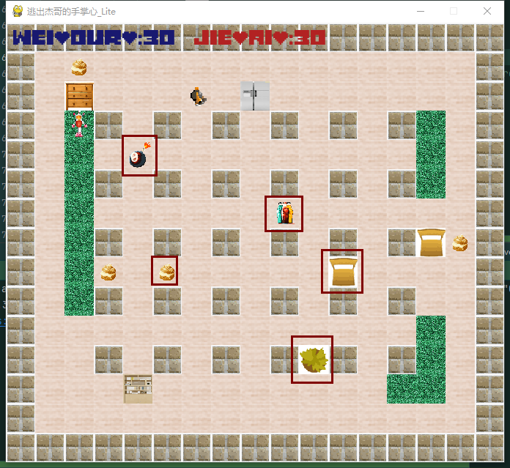
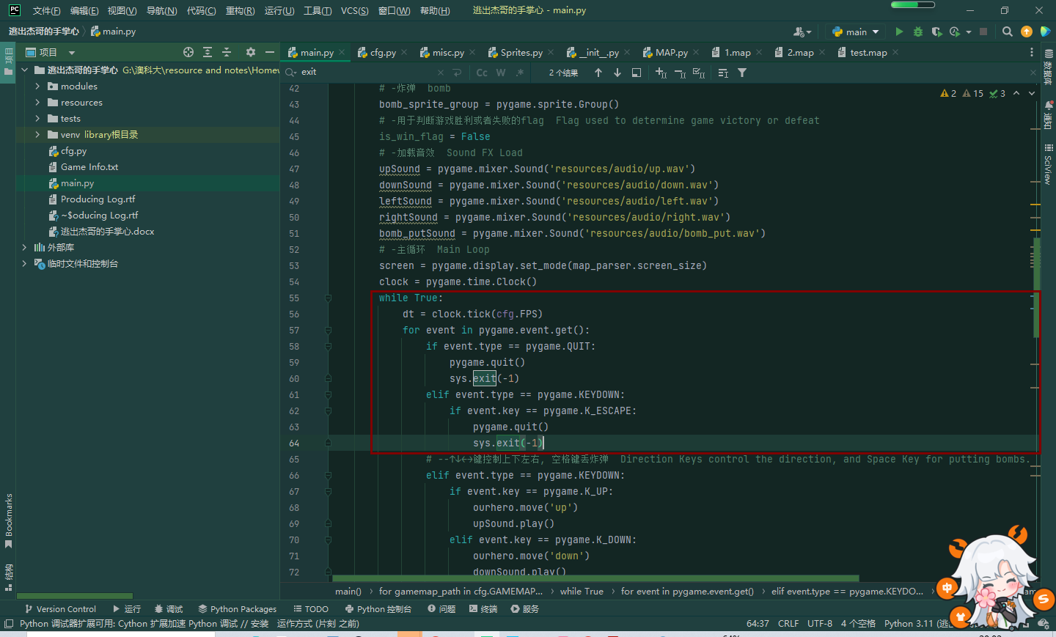

√ SOLVED | ~ SOLVING | × UNSOLVED

